**Event Injection Board**

# Description

Event Injection Board purpose is to inject a voltage at a specific event.

The main advantage of this device is injecting the voltage in less than 2ms from the event(stand-alone device - does not depend on OS).

Voltage injected can take values between 0 and 12V.

The event is a falling or a rising edge of a digital line of a Microcontroller.

This device has 6 input lines and 2 outputs.

Output can be connected to Arbitrary input of the FIB.

The device is configurable for each test.

Data are sent by serial from NeEVA. The configuration must be done when ECU is power off.

# Device configuration

Function used to configure the device:

GenerateTestConditions(input, output, edge, edgeNo, voltageStart, time1, voltage1, time2, voltage2, …)

* **Input** = 1 to 6 – line used as reference for triggering

Input must be a digital line.

* **Output** :
  + Output 1 generates voltages between 0 and 5V.
  + Output 2 generates voltages between 0 and 12V – used only for voltages over 5V, less precision.

Output must be connected from power off – disconnect the main line and connect the output to the microcontroller input

* **Edge** = 0 for falling and 1 for rising
* **Edge number** = number of falling/rising edge used for triggering
* **VoltageStart**([mV]) = voltage simulated from power off – used for not having other autotests failed(i.e when simulating at V+Tension or V-Tension if the voltage from power off is 0 then Motor Disconnected will be failed)
* **Time1**([ms]) = triggering time after event
* **Voltage1**([mV]) = voltage injected
* **Time2**([ms]) = triggering time after injection of voltage1, optional parameter
* **Voltage2**([mV]) = voltage injected after time2, optional parameter

Number of optional parameters is 9(9 time parameters and 9 voltage parameters).

E.g:

GenerateTestConditions(1, 1, 0, 2, 1000, 1, 3000, 200, 500, 200, 1000, 200, 2000, 200, 3000, 200, 4000, 200, 1000);

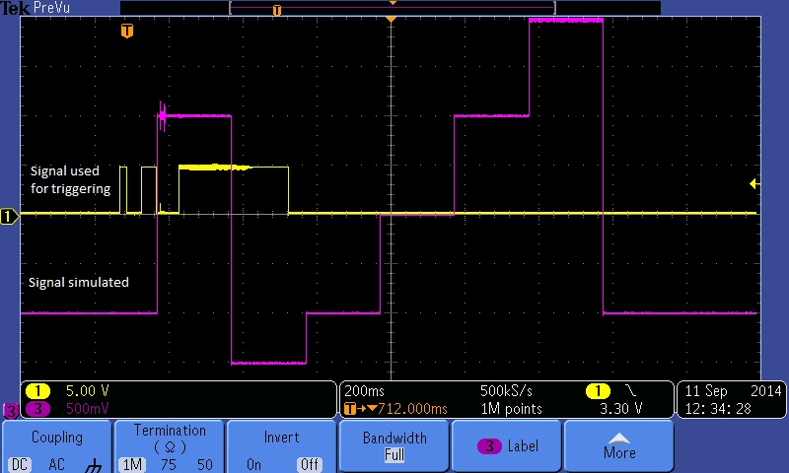

# Device connection

The inputs must be connected to microcontroller lines on Motor Board pins.

The output is connected to Arbitrary input on FIB.

Power supply = 12V

Communication with PC is done by serial.